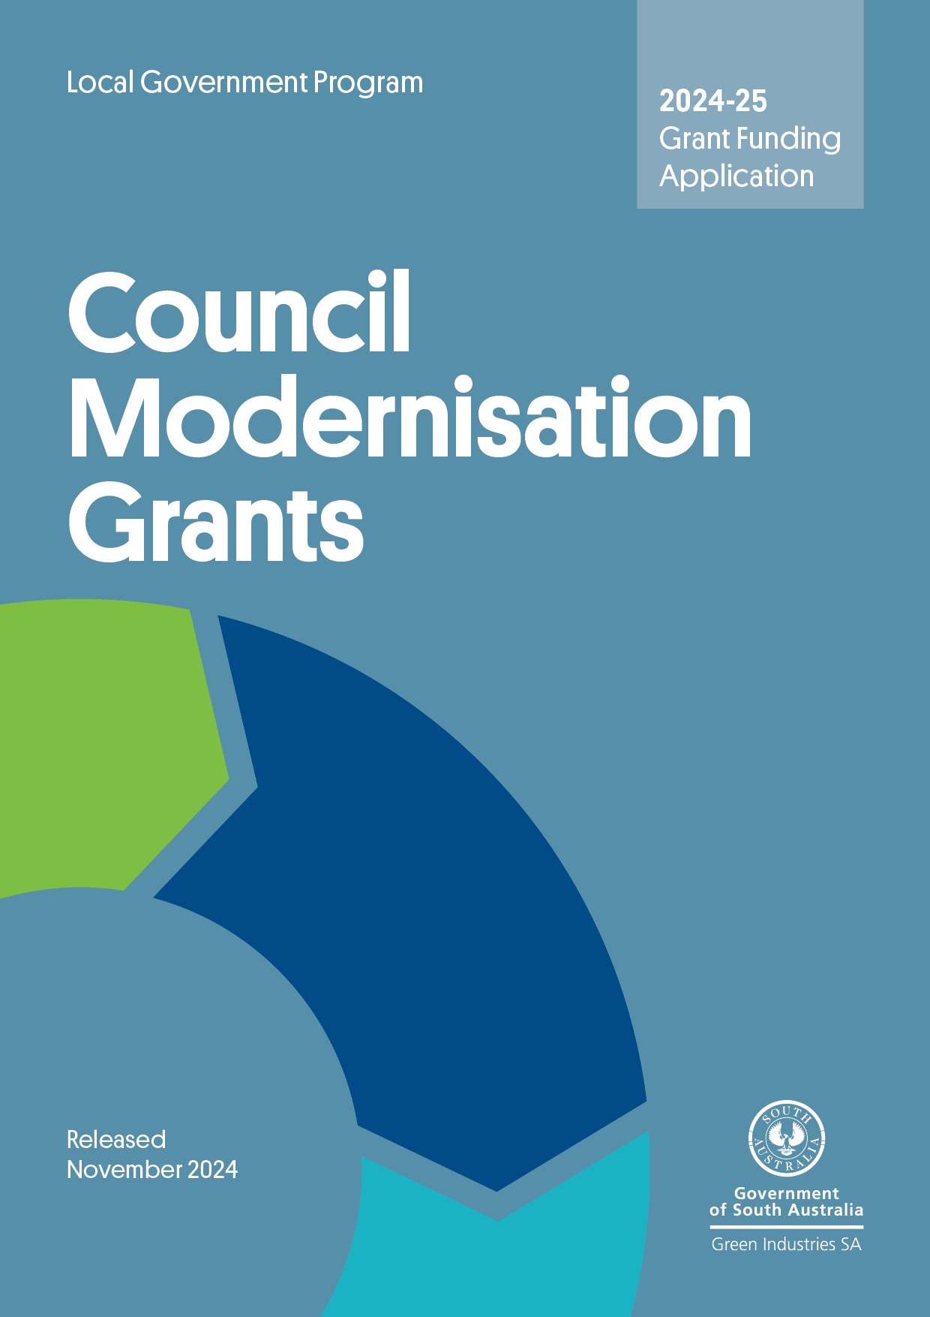

Program overview
The purpose of the Council Modernisation Grants Program is to encourage South Australia’s councils to improve waste management and recycling services through the introduction of innovative measures and increase implementation of circular economy principles. The modernisation measures should result in operational efficiencies, improved customer service and economic development benefits for the community.

Submitting your application
Applications will be accepted until 5 pm ACDT, Friday 13 December 2024. No late applications will be accepted.
Please email your completed application, including all supporting documents to:
justin.lang@sa.gov.au with the subject line Council Modernisation Grants – application. Emails should not exceed 10MB. Applications are to be no more than 20 pages (including supporting information).

Checklist
Before submitting your application, please check you have completed all the following:
- Read (in detail) and ensure you understand the Council Modernisation Grants Program Guidelines 2024–25
- Complete all relevant sections of the application form.
- Attach and clearly number evidence in support of the application.
- If applying for part funding toward a regional coordinator position, confirm in your application whether details are finalised or subject to Council consent

Need assistance?
Email justin.lang@sa.gov.au or telephone (08) 8429 8416 for more information and/or to check your eligibility.

Applicant information

Name of organisation
Australian Business Number (ABN)
Contact details
Name: |  |  | Position:
Tel: |  |  | Mobile:
Email: |  |  | Web:
Address:
Postal Address:
Type of modernisation project
Technology  Food waste reduction (including pilots)  Market research  Public place recycling |  |  |  | Regional waste management plan update  Regional Waste Coordinator (part funded position)  Other (specify)
Project summary (maximum 100 words) – why it’s needed, objectives and expected benefits (outcomes and outputs)
Proposed project start date |  |  |  |  | Proposed project completion date
Budget summary
GISA Grant  $ | Applicant contribution  $ |  |  | Other  $ |  |  | Total (exc. GST)  $
Is your organisation (tick one)
Lead organisation of a consortium or partnership |  |  |  |  |  | Sole applicant
If you are applying as the lead partner in this application, please provide the names of the other organisations in the project and outline the key role/responsibility for project delivery

Essential criteria check list
To be eligible for funding the project must meet the essential criteria below.
Essential criteria | Yes | No
Capacity to improve council waste and recycling services for better circularity
The proposal will achieve better outcomes for the council which are addressed in the application. For example, these would include one or more of the benefits below:
- Economic development
- Environmental
- Service delivery/operational efficiencies, reduced costs
- Community – improved customer satisfaction and engagement
Project Management
Capability and capacity to manage the project is demonstrated through adequate market research, staff experience, risk assessment, and appropriate evaluation of the project.

Timing
Demonstrate in the budget a timeframe for each step in the project process. Preference will be given to projects that can be delivered within 2 years from the grant offer.

Estimated budget
List items required for the project (excluding in-kind contributions, they should be added to the next table).
Funding from Green Industries SA can be sought for up to 50% of the project’s total budget and up to a maximum of $100,000 or up to 33% for Regional Coordinators. Insert additional lines if required in the table below.
Expenditure item description  (exclude in-kind items – add them to the separate table underneath) | Delivery date (estimated) | GISA funding sought  $ | Applicant contribution  $ | Other funding (specify source)  $ | Total cost of project  $ (GST ex)
Totals |  | $ | $ | $ | $
Green Industries SA funding as % of total funding

Please provide a breakdown of any in-kind contributions
Project element | Organisation providing in-kind contribution | Value of in-kind contribution
 |  | $
 |  | $
 |  | $
 | Total value of in-kind contribution | $
 | Total project budget | $

Regional Coordinator (where applicable)

Where a region wishes to submit details for a waste management Regional Coordinator, please detail the scope of works/projects to be completed, what contributions will be made by member councils, what in-kind contributions will be made for accommodation, IT support, and travel.

Who will be the host organisation?

Please detail the FTE/contact hours required.

What is the total investment per annum?

What outcomes will be delivered?

Proposed Coordinator’s work plan (may be attached separately):

If the position is proposed to be filled by existing staff from a member council, please submit their details below along with an overview of experience/qualifications for the role.

Name:

Current Position:

Role/Duties:

Relevant Experience/Expertise/Qualifications:

Has this proposal been endorsed by supporting councils? | Yes | No

Please provide details:

Project assessment criteria

Benefits of the initiative
Summarise the operational, environmental and/or community impacts arising from the project and attach supporting evidence.

Summarise any anticipated economic development benefits such as business expansion, supply chain benefits and/or employment growth and attach supporting evidence.

Project viability
Summarise the business case (and attach more detailed documents) to demonstrate how the project will result in:
- Economic development benefits, and/or
- Reduced costs and/or more efficient and effective services, and/or
- Improved public place recycling.

Contribution to the circular economy (if relevant)
Explain how the project will foster local economic activity and help reduce emissions and waste, and help achieve circular economic development objectives.

Waste management hierarchy (if relevant)
How does your project target the higher levels of the waste management hierarchy, where materials are used for their highest order purpose?

Value for money
How are grant monies leveraged with other funding? Is there an existing budget allocation for this project?

Performance measurement
How will you measure the impact and outcomes of the project?
What are the Key Performance Indicators for the project?
When will you measure the impact and outcomes of the project?

Assessment Criterion: capacity and capability to manage the project
- Explain and demonstrate your organisation’s capacity and capability to manage and deliver the project successfully with sufficient commitment and experience, including:
- detailing how your organisation will manage the project and relevant experience
- indicating the anticipated roles of sub-contractors and how they will be managed (if you intend to use sub-contractors).
Key people involved in the project (please add additional rows if necessary)
Name: | Position
Role in this project and relevant experience/expertise

Name: | Position
Role in this project and relevant experience/expertise

Information on sub-contractors and/or other organisations involved (if applicable)
- Describe the capacity of your organisation to implement the project successfully, such as financial viability, any supporting partnerships, and an understanding of the relevant regulatory requirements.

Approvals
Does your project require any other council, state or federal government approvals? If yes, what are these, and have the approvals been obtained/when are they likely to be obtained? Note: if your project requires any form of approval, the project will not start until Green Industries SA has received confirmation of the approval.

Intellectual Property
What Intellectual Property will be created through this project? How will it be shared?

Risk management (mandatory)
Identify the potential risks to the project and described actions to mitigate or minimise these risks.

Supporting information
Please indicate the documentation attached in support of your application.

 | Information supplied | Yes | No | N/A | Attachment No.
 | Business plan/business case
 | Project management plan
 | Cost estimates/quotes for proposed technology, infrastructure, or professional consultancy service/s
Role description (Regional Coordinator)
 | Market research/community impact analysis
 | Data analysis, economic modelling or other evidence to support assumptions
 | Other (specify)

Declaration

- I/we have read and understood the Guidelines and obtained clarification where needed.
- I/we declare that the information provided in this application including attachments is true and correct and discloses all required and relevant details.
- I/we understand that if information supplied as part of the application is false or misleading in a material particular, the application will not be considered OR, if the grant is made and it is discovered that information supplied was false or misleading in a material particular, the grant will be revoked and funds, plus interest, must be repaid. An assessment regarding possible fraud will also be undertaken and appropriate legal action initiated if warranted.
- I/we authorise Green Industries SA to seek any additional relevant information required to process this application, and I/we hereby request and authorise any parties to supply such information as requested.
- I/we understand that if the project is approved for funding, information about the project may be publicised by Green Industries SA or provided as required or permitted by law.
- If the project is approved for funding, I/we will obtain all necessary and appropriate clearances from the relevant Commonwealth, state or local governments (if applicable) before executing the grant agreement and undertake to manage the proposed project in accordance with relevant laws and regulations.
- If I/we accept an offer of funding, then I/we accept (jointly and severally in the case of a group application) responsibility for administering grant funds and liability in the event grant funds are to be repaid.
Signed
Name
Position
Date

The Chief Executive, or Chief Executive’s delegate of your organisation must sign the application form. It should not be signed by the contact person unless the contact person is the Chief Executive or delegate.

Total project budget is the total cost of the project plus in-kind contributions.

